**Issue 1**

On the home page libertyvan text elements overlap with peactures

**Used Device/Browser:**

- Chrome (Version Version 80.0.3987.116 (Official Build) (64-bit) on Windows 10

**Steps to reproduce:**

- Open the <http://www.libertyvan.com/> page

- The Home page will be displayed

- Check the page

- It is not displayed correctly

- Text elements overlap

Screenshot:

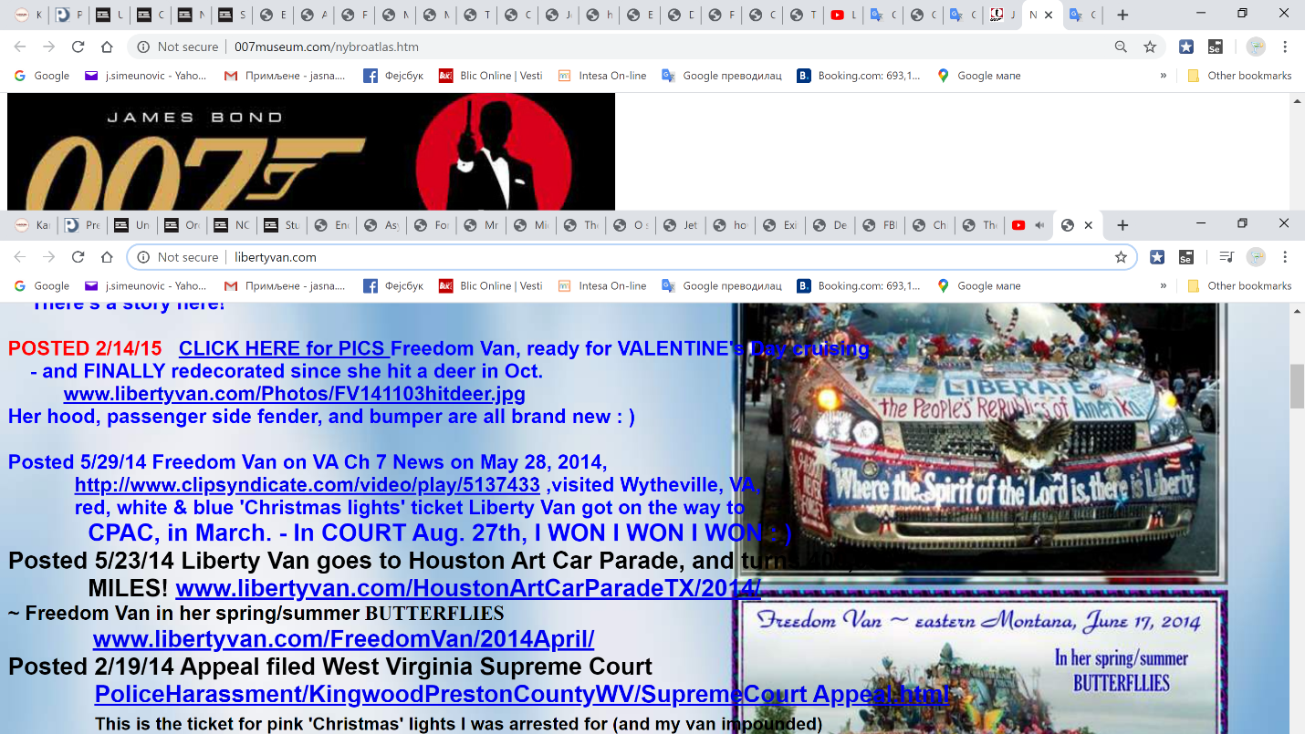

**Issue 2**

On the lhosanna1 page the all elemnents on the page are placed in no order

**Used Device/Browser:**

- Chrome (Version Version 80.0.3987.116 (Official Build) (64-bit) on Windows 10

**Steps to reproduce:**

- Open the <http://www.libertyvan.com/>page

- Click on the link [**www.hosanna1.com/Hounds/**](http://www.hosanna1.com/Hounds/)

- The entre page will be displayed

- scroll down

- Check the page

- It is not displayed correctly

- The all elemnents on the page are placed in no order

Screenshot:

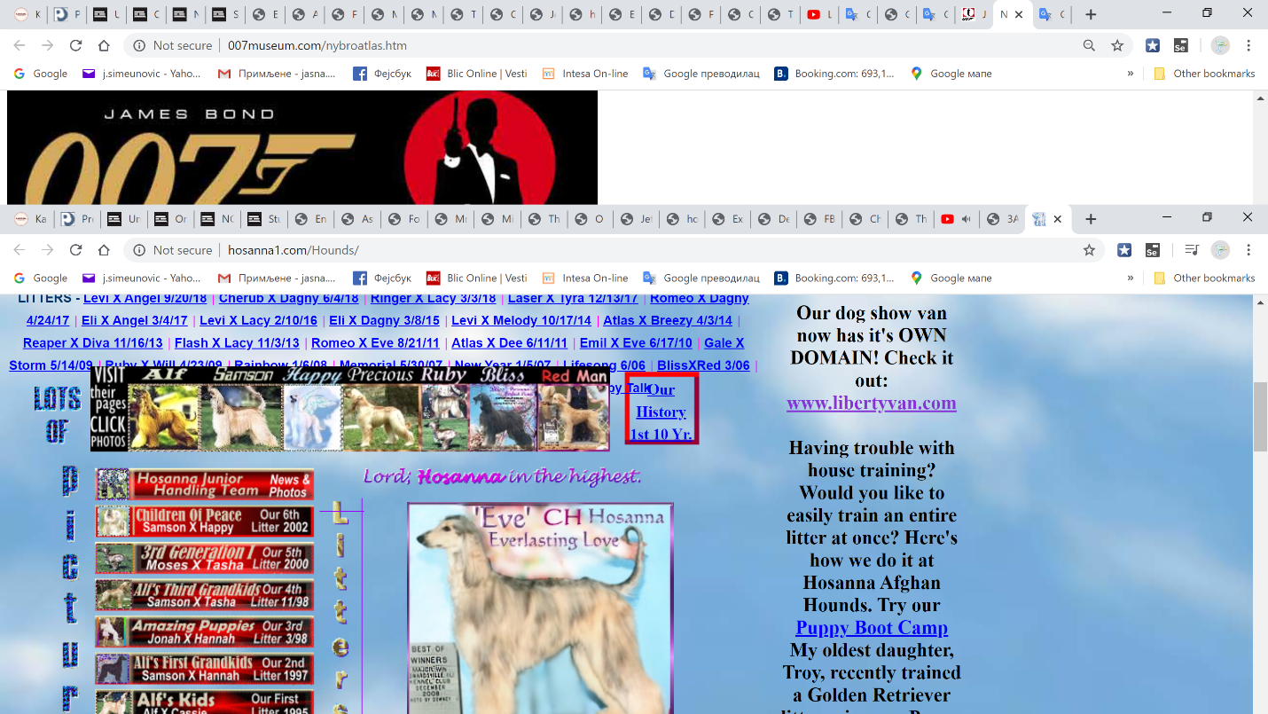

**Issue 3**

On the page Freedom Van/2014 April/ the picture aten't uploaded

**Used Device/Browser:**

- Chrome (Version Version 80.0.3987.116 (Official Build) (64-bit) on Windows 10

**Steps to reproduce:**

- Open the <http://www.libertyvan.com/>page

- Click on the link [**www.libertyvan.com/FreedomVan/2014April/**](http://www.libertyvan.com/FreedomVan/2014April/)

- The entre page will be displayed

- scroll down

- Check the page

- It is not displayed correctly

- The picture aten't uploaded

Screenshot:

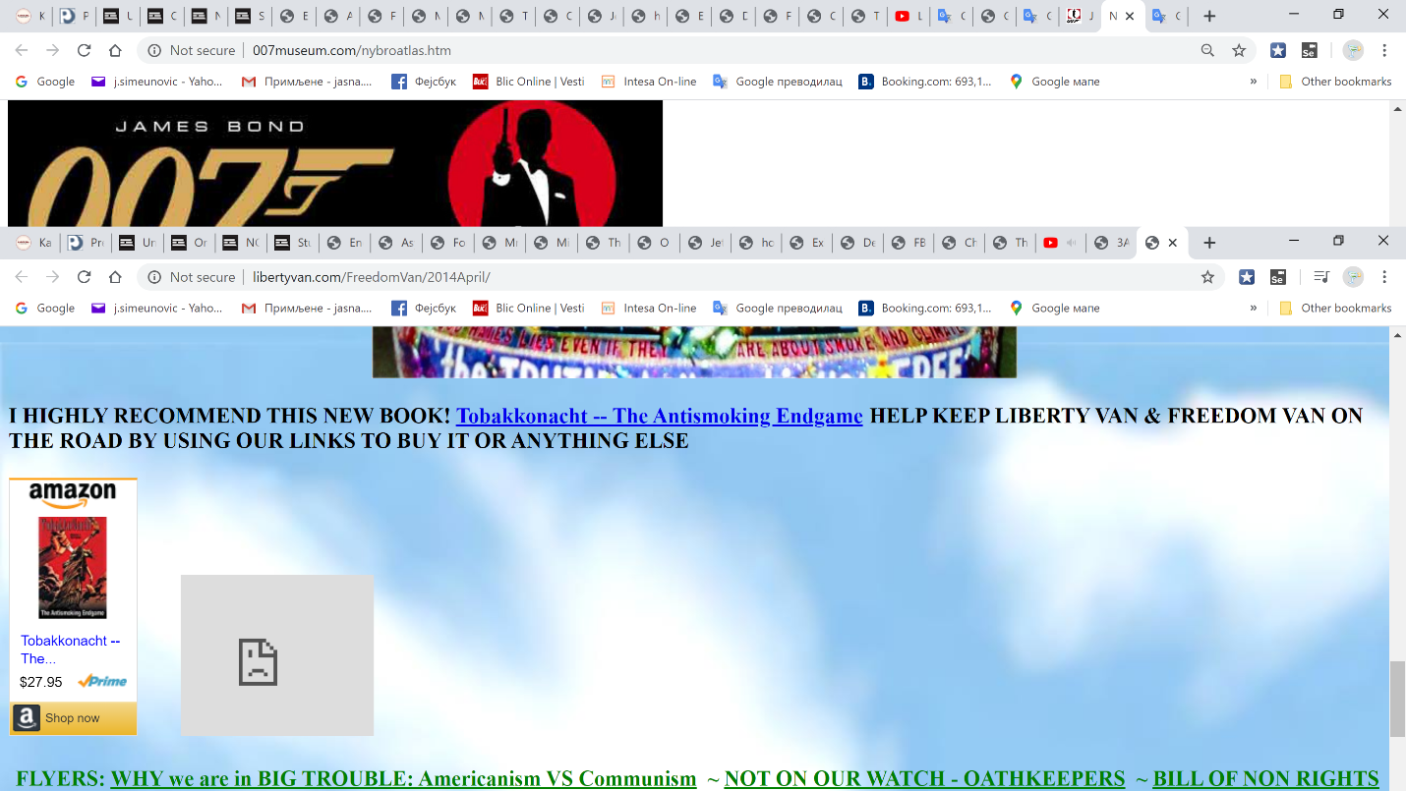

**Issue 4**

Tink to page Great parade photos leads to an unavailable page

**Used Device/Browser:**

- Chrome (Version Version 80.0.3987.116 (Official Build) (64-bit) on Windows 10

**Steps to reproduce:**

- Open the <http://www.libertyvan.com/>page

- Click on the link [**Liberty Van #108, 109  ~  Freedom Van 110  OF 200**](http://www.facebook.com/photo.php?fbid=10150305457167802&set=a.10150305454952802.405589.43766522801&type=1&ref=nf#!/photo.php?fbid=10150305470887802&set=a.10150305454952802.405589.43766522801&type=1&pid=9466509&id=43766522801)

- The entre page will be displayed

- It is not displayed correctly

- The page isn't available

Screenshot:

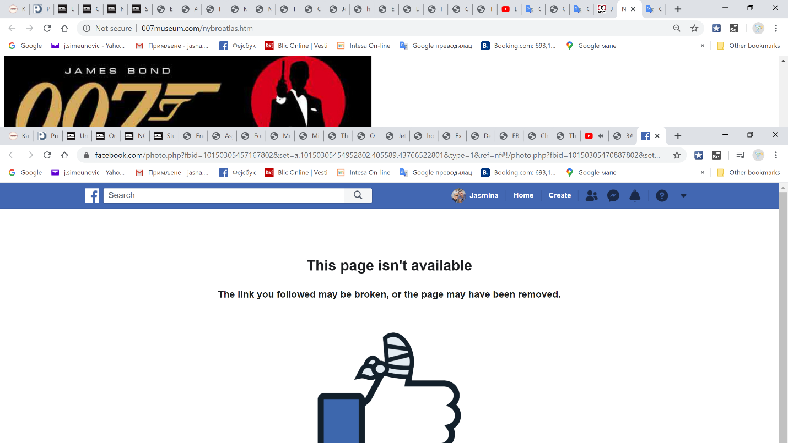

**Issue 5**

Link send this link to a friend don't work

**Used Device/Browser:**

- Chrome (Version Version 80.0.3987.116 (Official Build) (64-bit) on Windows 10

**Steps to reproduce:**

- Open the <http://www.libertyvan.com/>page

- Click on the link NEW! *** SEND THIS LINK TO A FRIEND! [**CLICK HERE**](mailto:?subject=ART%20car%20pictures%20&body=http://www.libertyvan.com/)

- The entre page will not be displayed

Screenshot:

<https://recordit.co/ya6Kf87Bcv>